***Group 2 Portfolio Management Project***

**FINA 8663: Investment Analysis**

**Thakkar Bansi, Boahen Ohene,**

**Phan Nghia Duc, Zhe Chen,**

**Frem Boustani Fadi, Lui Wenxi**

**November 30, 2025**

**Investment Policy Statement**

*Investment philosophy*

The portfolio is built around long-term value creation through fundamental analysis. The approach relies on the market eventually recognizing the intrinsic worth of strong businesses, even if prices fluctuate in the short run. The focus is on companies with steady cash flows, durable competitive advantages, and valuations that fairly reflect their fundamentals. Growth stocks are included only when they show a clear and realistic path to sustainable profitability. Overall, the philosophy remains patient, research-driven, and disciplined.

*Investment objectives*

The primary objective is to achieve steady capital appreciation that keeps pace with the benchmark over full market cycles. The portfolio emphasizes risk-adjusted returns rather than short-term price movements. Preserving capital during market downturns is a priority, and investments lacking financial stability are avoided. Dividend income is acceptable but not the main focus; instead, returns are driven by strong security selection and consistent risk management.

*Investment constraint*

The portfolio follows a fixed twenty-year horizon, which supports a long-term outlook and tolerance for temporary volatility. Liquidity needs are low since the intention is to remain mostly invested. Cash holdings are kept between 0–2% for operational needs or to take advantage of compelling opportunities.

A clear sell discipline is followed. If a position falls more than 30% from cost, it is reviewed to determine whether the decline reflects a structural problem or short-term pressure. Annual turnover is kept below 15% to support compounding and reduce unnecessary trading.

*Risk tolerance*

The risk tolerance is moderate and aligned with the long investment horizon. Normal market fluctuations are acceptable as long as the underlying business fundamentals remain intact. Permanent loss of capital is not acceptable. Companies with excessive leverage, unstable earnings, or speculative business models are avoided. Each position is evaluated based on valuation, financial strength, and competitive advantage.

*Time horizon*

The portfolio has a long-term horizon measured in years, not months. This allows the benefits of compounding to take effect and provides the flexibility to hold positions through temporary market downturns when the long-term outlook remains strong.

*Asset allocation*

The allocation reflects a conservative, value-oriented approach. Sector weights favor stable, cash-generating industries while keeping exposure to high-volatility areas controlled. The target weights are:

* **Consumer Staples & Beverages – 22%** (PG, KO)
* **FMCG – 23%** (MNST, HSY)
* **Healthcare – 23%** (NVO, NVS)
* **Technology – 12%** (MSFT, NVDA)
* **Aerospace & Defense – 10%** (LMT)
* **Energy – 10%** (TTE)

This structure diversifies the portfolio while reducing concentration in technology. Individual holdings generally fall within the 7–13% range to maintain balance without diluting impact.

*Liquidity and trading*

Liquidity is maintained at a level adequate to meet any expected needs. Trading is intentional and driven by changes in fundamentals, valuation gaps, or risk considerations—never by short-term market noise. Turnover remains low to support compounding and keep costs minimized.

*Review and oversight*

The portfolio is reviewed monthly to ensure it remains aligned with core objectives and the underlying fundamentals of each holding. Rebalancing is performed when sector weights drift more than 3% from targets, with attention given to transaction costs. The IPS is reviewed annually for continued relevance. A quarterly performance update is provided to clients, including rebalancing activity, company-specific news, and forward-looking insights.

**Investment strategies**

The strategy seeks securities trading below intrinsic value, based on the belief that market prices often disconnect from fundamentals in the short term. The focus remains on companies with stable earnings, strong financial positions, and durable business models.

A bottom-up approach is used. Each company is evaluated through financial statements, competitive position, management quality, and long-term prospects. Value stocks form the foundation of the portfolio, with growth stocks added selectively when supported by reliable profitability expectations.

The benchmark for performance is the S&P 500 Total Return Index, which offers a broad, diversified standard for long-term comparison. Allocation decisions also consider beta: higher-beta companies, such as NVDA, receive smaller weights to manage volatility, while lower-beta, defensive companies like PG and NVS receive higher weights to help balance risk and return.

**Portfolio Holdings, Value, and Performance History**

Returns shown reflect price changes from September 17 to November 20, 2025, without reinvesting dividends. We use the S&P 500 as our benchmark since our portfolio focuses on large-cap U.S. stocks similar to those in the index. Returns are calculated before taxes and transaction costs. Past performance does not indicate future results.

*Holding Period Return (Ending November 20)*  *Portfolio Overview*

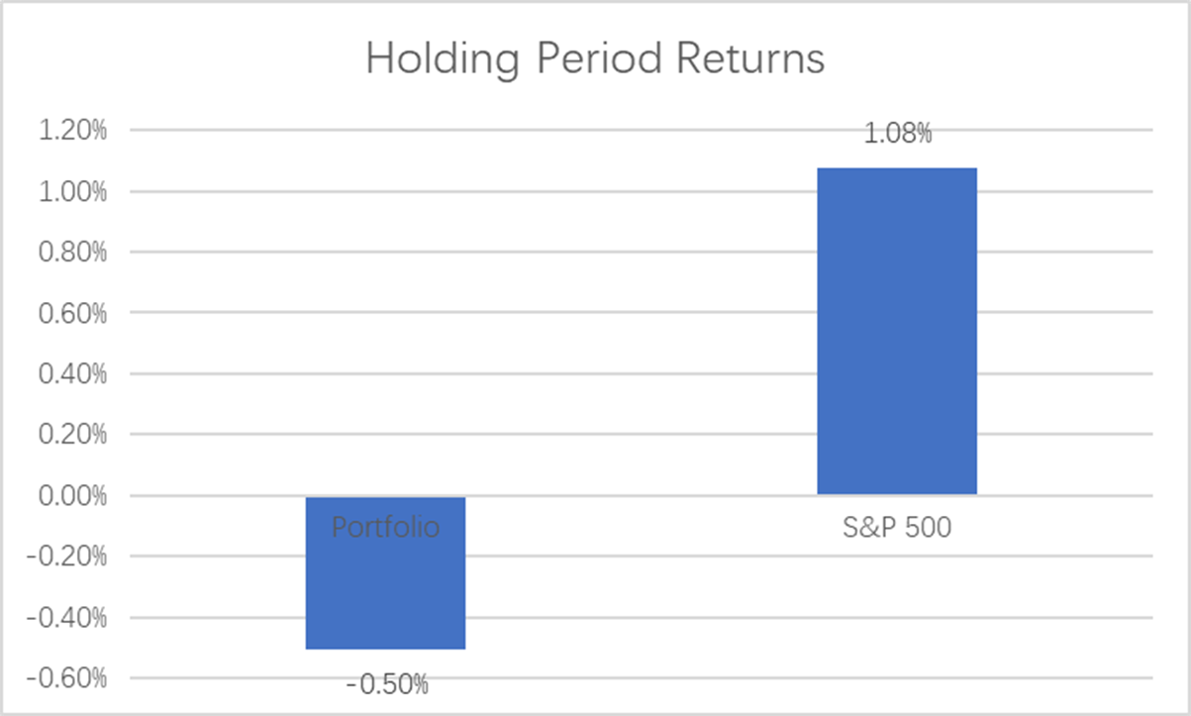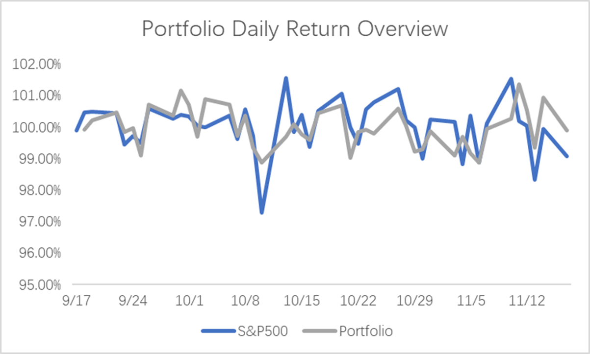

*Portfolio Holdings as of November 20*

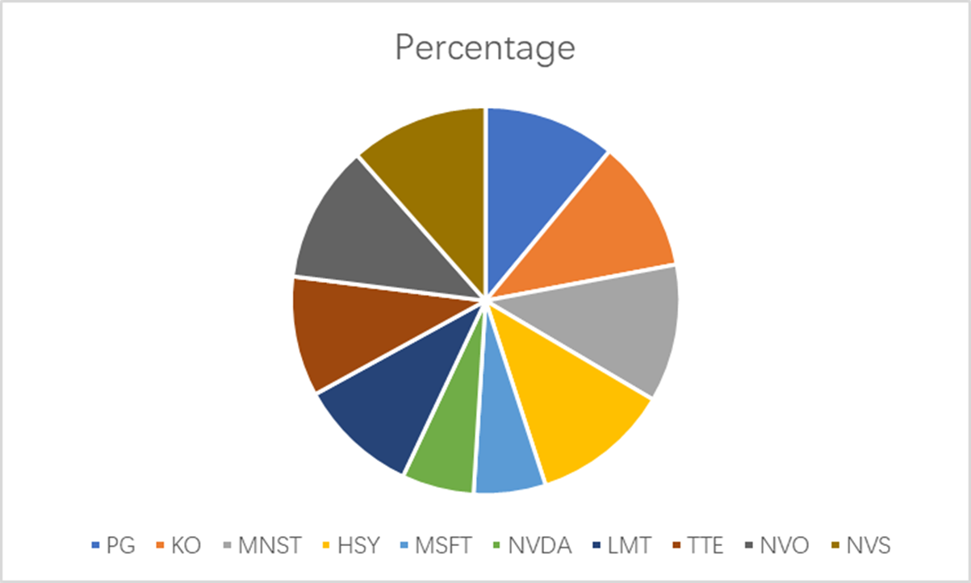

**Discussion of Fund's Performance**

Over the three-month period from September 17 to November 20, 2025, the portfolio generated a holding period return of -0.5%, underperforming the S&P 500's return of 1.08% by 158 basis points. This underperformance occurred despite strong showings from several individual holdings.

The portfolio's bright spots included NVIDIA and Monster Beverage. NVIDIA benefited from surging demand for AI infrastructure and GPU-accelerated computing, which drove strong revenue growth and supported the stock's appreciation. Monster Beverage also contributed positively, with expanding international distribution and successful new product launches strengthening both sales volumes and market share.

However, several holdings faced significant headwinds. Novo Nordisk emerged as the portfolio's largest detractor, declining sharply due to intensifying competition in the GLP-1 market, disappointing Phase 3 clinical trial results, and ongoing pricing pressure from payers. The company's struggles were compounded by broader pharmaceutical sector concerns about pricing reform.

Consumer staples holdings, particularly Procter & Gamble, also faced challenges. Rising input costs from tariff implementations compressed margins, while persistent inflation reduced consumer purchasing power for premium-priced products. These pressures manifested in weaker-than-expected earnings and subsequent stock price weakness.

Despite near-term underperformance, we remain constructive on the portfolio's long-term prospects. Our investment philosophy emphasizes sustained value creation over extended periods rather than short-term price movements. The three-month evaluation window may amplify the impact of temporary factors while understating the fundamental strengths of our holdings. Each company in the portfolio maintains competitive advantages in its respective industry, generating the stable cash flows and market positions that should support recovery and growth over our twenty-year horizon.

**Ex-Dates over the Three-Month Span**

|  |  |  |  |  |  |
| --- | --- | --- | --- | --- | --- |
| **Stock** | **Percentage** | **Div Per Share** | **Ex-Divident Date** | **Pay Date** | **Total Dividend** |
| *PG* | 11.00% | $1.06 | 2025/10/24 | 2025/11/17 | $72.08 |
| *HSY* | 11.50% | $1.37 | 2025/11/17 | 2025/12/15 | $82.2 |
| *MSFT* | 6.00% | $0.91 | 2025/11/20 | 2025/12/11 | $10.01 |
| *TTE* | 10.00% | $0.99 | 2025/09/30 | 2025/10/22 | $161.37 |

***Note:* *Stocks not mentioned here had ex-dates outside our holding period and are excluded.***

Our stock picks were not driven by dividend yields alone. We looked for companies with solid fundamentals and real long-term potential, then built a portfolio that balances growth with protection against downside risk.

We allocated 12% to Technology, split evenly between Microsoft and NVIDIA at 6% each. This gives us exposure to the AI boom and enterprise software growth without overconcentrating in the market's most volatile sector. The pairing works well because Microsoft's steadier business model (beta 0.96) offsets some of NVIDIA's higher risk profile (beta 2.21). Both stocks performed well during our holding period as AI adoption accelerated.

The bulk of our portfolio, 68%, sits in more defensive sectors. Healthcare makes up 23% with equal positions in Novo Nordisk and Novartis. Consumer Staples and Beverages account for 22% through Procter & Gamble and Coca-Cola, both companies that tend to hold up well regardless of economic conditions. FMCG is another 23% via Monster Beverage and Hershey. We rounded out the portfolio with Lockheed Martin in Aerospace and Defense at 10% and TotalEnergies in Energy at 10%. This mix produced a portfolio beta of 0.56, meaning we are taking on about half the volatility of the overall market. That lower risk profile aligns with our goal of steady growth over the long term.

**Portfolio Characteristics**

*Beta Breakdown by Asset*

|  |  |  |
| --- | --- | --- |
| **Ticker** | **Beta** | **Weight** |
| *NVDA* | 2.21 | 6.00% |
| *MSFT* | 0.96 | 6.00% |
| *TTE* | 0.71 | 10.00% |
| *PG* | 0.54 | 11.00% |
| *MNST* | 0.54 | 11.50% |
| *NVS* | 0.45 | 11.50% |
| *KO* | 0.43 | 11.00% |
| *NVO* | 0.32 | 11.50% |
| *HSY* | 0.27 | 11.50% |
| *LMT* | 0.12 | 10.00% |
| ***Portfolio*** | ***0.56*** | ***100.00%*** |

*Total Portfolio Beta = 0.56*

The portfolio beta of 0.56 confirms our defensive positioning, indicating significantly lower volatility than the S&P 500's beta of 1.0. We achieved this through substantial allocations to low-beta defensive stocks such as Lockheed Martin (0.12), Hershey (0.27), and Novo Nordisk (0.32), which together comprise approximately 33% of the portfolio. For Technology exposure, we allocated 12% equally between Microsoft and NVIDIA at 6% each. This pairing allows us to capture AI-driven growth through NVIDIA's high beta (2.21) while using Microsoft's more moderate beta (0.96) to balance overall portfolio volatility.

**Attribution Analysis**

*Sector Returns Overview*

|  |  |  |
| --- | --- | --- |
| **Sector** | **Fund Return (Calibrated)** | **Benchmark Return (S&P 500)** |
| *Healthcare* | -7.80% | 10.87% |
| *Energy* | 5.90% | -0.41% |
| *Consumer Staples* | 1.60% | -3.30% |
| *Technology* | 0.50% | 0.39% |
| *Industrials* | -0.50% | -1.79% |

*Returns Due to Allocation*

The portfolio's underperformance relative to the S&P 500 can be decomposed into two components: allocation effects (sector weighting decisions) and selection effects (individual stock choices within sectors). Our attribution analysis reveals that allocation decisions contributed a modest positive 0.04% to relative performance, while stock selection detracted -1.31%, resulting in total underperformance of -1.27% relative to the benchmark.

|  |  |  |  |  |  |
| --- | --- | --- | --- | --- | --- |
| **Sector** | **Fund Weight** | **Benchmark Weight** | **Difference** | **Benchmark Return** | **Contribution** |
| *Healthcare* | 23.00% | 9.00% | 14.00% | 10.87% | **1.52%** |
| *Technology* | 12.00% | 36.10% | -24.10% | 0.39% | **-0.09%** |
| *Energy* | 10.00% | 2.80% | 7.20% | -0.41% | **-0.03%** |
| *Industrials* | 10.00% | 8.10% | 1.90% | -1.79% | **-0.03%** |
| *Consumer Staples* | 45.00% | 4.70% | 40.30% | -3.30% | **-1.33%** |
| *Total Allocation* |  |  |  |  | **0.04%** |

*Returns Due to Selection*

Our allocation decisions produced mixed results. The decision to overweight Healthcare (23% versus the benchmark's 9%) proved beneficial, as the sector generated benchmark returns of 10.87%, contributing +1.52% to portfolio performance. This overweight position capitalized on the sector's relative strength during the period.Conversely, our combined 45% allocation to Consumer Staples and FMCG sectors significantly exceeded the benchmark's 7% weighting. While this defensive positioning aligned with our risk management objectives, it detracted -1.33% from relative performance as both sectors underperformed their benchmarks. Consumer Staples faced margin pressure from elevated input costs and persistent inflation, limiting returns despite the sectors' stability characteristics

|  |  |  |  |  |  |
| --- | --- | --- | --- | --- | --- |
| **Sector** | **Fund Return** | **Benchmark Return** | **Difference** | **Fund Weight** | **Contribution** |
| *Healthcare* | -7.80% | 10.87% | -18.67% | 23.00% | **-4.29%** |
| *Technology* | 0.50% | 0.39% | 0.11% | 12.00% | **0.01%** |
| *Energy* | 5.90% | -0.41% | 6.31% | 10.00% | **0.63%** |
| *Industrials* | -0.50% | -1.79% | 1.29% | 10.00% | **0.13%** |
| *Consumer Staples* | 1.60% | -3.30% | 4.90% | 45.00% | **2.21%** |
| *Total Selection Effect* |  |  |  |  | **-1.31%** |

*Risk and Performance Analysis*

|  |  |  |
| --- | --- | --- |
| **Metric** | **Portfolio** | **Benchmark (S&P 500)** |
| *Average Beta* | 0.56 | 1 |
| *Holding Period Return* | -0.50% | 1.08% |
| *Standard Deviation* | 0.64% | 0.82% |
| *Treynor Ratio* | -0.0008 | -0.0004 |
| *Jensen's Alpha* | 0.00% | N/A |
| *Sharpe Ratio* | -0.07 | -0.049 |
| *Variance* | 0.00004129 | 0.00006801 |

The portfolio maintained a beta of 0.56, approximately half the market's systematic risk, resulting in lower volatility as measured by a standard deviation of 0.64% compared to the market's 0.82%. However, the portfolio generated a holding period return of -0.50%, underperforming the S&P 500 by 1.58 percentage points.

This underperformance was not attributable to systematic flaws in our value-oriented strategy, but rather reflected company-specific challenges in key holdings. Novo Nordisk faced clinical trial setbacks and competitive pressures in the GLP-1 market, while Procter & Gamble experienced margin compression from elevated input costs. These individual stock headwinds overshadowed positive contributions from other holdings during the period.

The negative Sharpe ratio of -0.07 and Treynor ratio of -0.0008 reflect the challenging environment where returns barely exceeded the risk-free rate. Notably, the S&P 500 also posted negative risk-adjusted returns (Sharpe of -0.049), indicating broad market difficulties during this period. Jensen's Alpha of approximately 0.00% suggests the portfolio performed in line with risk-adjusted expectations given its defensive beta positioning.

Despite near-term underperformance, we maintain conviction in these holdings given their durable competitive advantages, sound balance sheets, and proven management teams. The three-month evaluation period may not fully capture the value creation potential of our long-term, fundamentals-based approach.

**Team Organization and Operations**

Our team of six members collaborated throughout the semester, meeting weekly to discuss portfolio decisions and project progress.

***Thakkar Bansi*** - Built initial Excel portfolio framework and coordinated project integration, managing timeline adherence and quality assurance across all deliverables.

***Frem Boustani Fadi***  - Developed Excel sheets 3-5 (individual stock analysis, market data, and performance metrics) including all beta, risk, and return calculations.

***Boahen Ohene*** - Created all visual exhibits, charts, and appendix materials while ensuring professional presentation standards throughout the report.

***Zhe Chen*** - Wrote the Portfolio Characteristics section analyzing risk metrics and conducted market research for September-November 2025 performance context.

***Phan Nghia Duc***- Authored the Investment Policy Statement and Investment Strategies sections establishing portfolio objectives, constraints, and allocation framework.

***Lui Wenxi*** - Wrote Portfolio Holdings and Performance History sections including holding period analysis, performance discussion, and market commentary.

Our team maintained regular communication through shared Google Drive folders and weekly meetings to coordinate deliverables and ensure consistency across all sections.

**Appendix**

*Exhibit 1: Sector Dividend Yield (*Reference: <https://finance.yahoo.com/> )

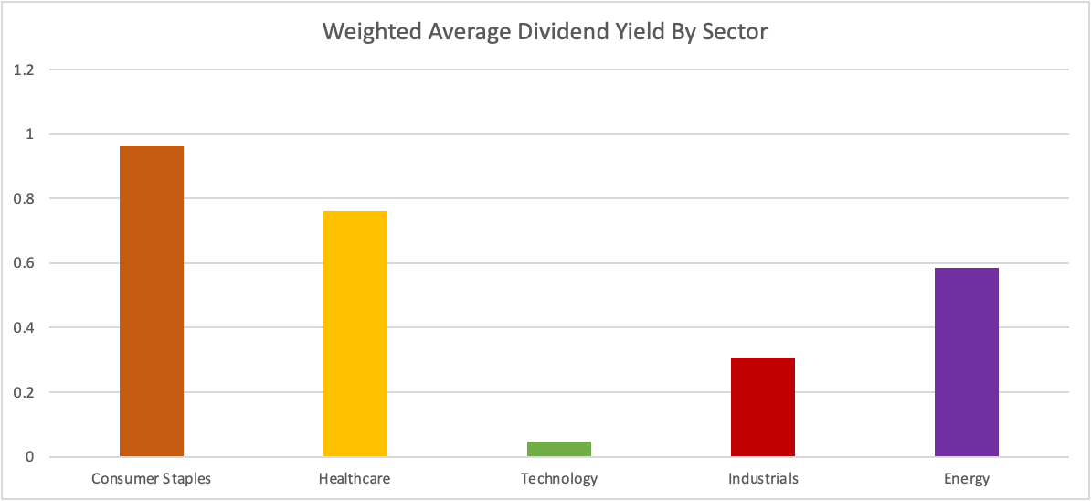

*Exhibit 2: Equity Selection*

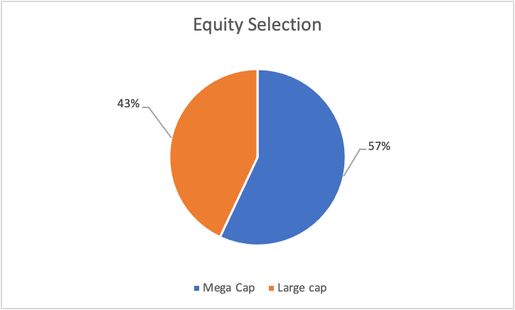

*Exhibit 3: Sector Return Bar Graph*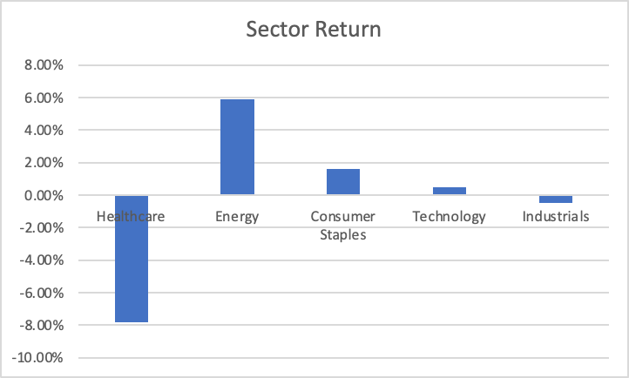

*Exhibit 4: Sector Returns Table Data*

|  |  |
| --- | --- |
| **Sector** | **Sector Return** |
| **Healthcare** | -7.80% |
| **Energy** | 5.90% |
| **Consumer Staples** | 1.60% |
| **Technology** | 0.50% |
| **Industrials** | -0.50% |

*Exhibit 5: Asset performance as of 11/20/2025*

